

# A REPORT ON

**Sustainable Energy Systems**

### Is Submitted in Partial Fulfillment of The Requirements for the Degree of THIRD YEAR OF ENGINEERING

In

### COMPUTER ENGINEERING DEPARTMRNT

By

**Rohit Dadarao Chilhorkar**

**(13106)**

**Under the Guidance of Prof. Supriya B. Boraste**

### DEPARTMENT OF COMPUTER ENGINEERING

Dr. D. Y. Patil College of Engineering and Innovation Varale, Talegaon-410507

**T.E Sem-II, 2021-2022**

# Introduction

Energy systems worldwide are undergoing a major transformation as a consequence of the transition towards the widespread use of clean and sustainable energy sources. The electric power system in a sustainable future will augment the centralized and large-grid-dependent systems of today with distributed, smaller-scale energy generation systems that increasingly adopt renewable energy sources (e.g., solar and wind) and rely on cyber technologies to ensure resiliency and efficient resource sharing. Basically, this involves massive changes in technical and organizational levels together with tremendous technological upgrades in different sectors ranging from the energy generation and transmission systems down to the distribution systems.

These actions constitute a huge science and engineering challenges and demands for expert knowledge in the field to create solutions for a sustainable energy system (both at the energy supply and demand sides) that is economically, environmentally, and socially viable while meeting high security requirements. On energy consumers’ side, useful and efficient energy services such as light, heating and cooling, cooking, communication, power, and motion are needed. These services are offered by specific equipment/devices, which use energy blocks either efficiently or inefficiently. Producing energy with high environmental, societal, or health risks is not a cheap way to meet such energy demand, but packages of efficient equipment and energy at least societal costs, which includes external costs, should be the ultimate objective to satisfy the needs of customers. At the supply side, there exists a bunch of opportunities for renewable energy technologies complemented with energy efficiency measures not only to provide local benefits, but also to contribute to sustainable development, which is framed in a three-pillar model: Economy, Ecology, and Society. Thus, the relationship between the use of renewables in energy mix and the sustainable developments goals (SDGs) can be viewed as a set of objectives and constraints that involve both global and local/regional considerations.

## The most popular renewable energy sources currently are:

1. Solar energy
2. Wind energy
3. Hydro energy
4. Tidal energy
5. Geothermal energy
6. Biomass energy

## SOLAR ENERGY –

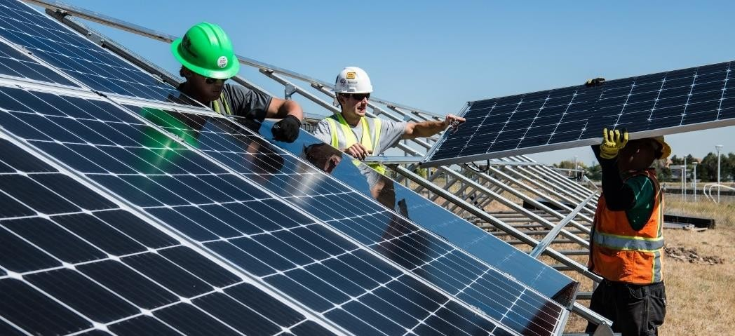s

Sunlight is one of our planet’s most abundant and freely available energy resources. The amount of solar energy that reaches the earth’s surface in one hour is more than the planet’s total energy requirements for a whole year. Although it sounds like a perfect renewable energy source, the amount of solar energy we can use varies according to the time of day and the season of the year as well as geographical location. In the UK, solar energy is an increasingly popular way to supplement your energy usage.

Solar energy, radiation from the Sun capable of producing heat, causing chemical reactions, or generating electricity. The total amount of solar energy incident on Earth is vastly in excess of the world’s current and anticipated energy requirements. If suitably harnessed, this highly diffused source has the potential to satisfy all future energy needs. In the 21st century solar energy is expected to become increasingly attractive as a renewable energy source because of its inexhaustible supply and its nonpolluting character, in stark contrast to the finite fossil fuels coal, petroleum, and natural gas.

The Sun is an extremely powerful energy source, and sunlight is by far the largest source of energy received by Earth, but its intensity at Earth’s surface is actually quite low. This is essentially because of the enormous radial spreading of radiation from the distant Sun. A relatively minor additional loss is due to Earth’s atmosphere and clouds, which absorb or scatter as much as 54 percent of the incoming sunlight. The sunlight that reaches the ground consists of nearly 50 percent visible light, 45 percent infrared radiation, and smaller amounts of ultraviolet and other forms of electromagnetic radiation.

## WIND ENERGY-

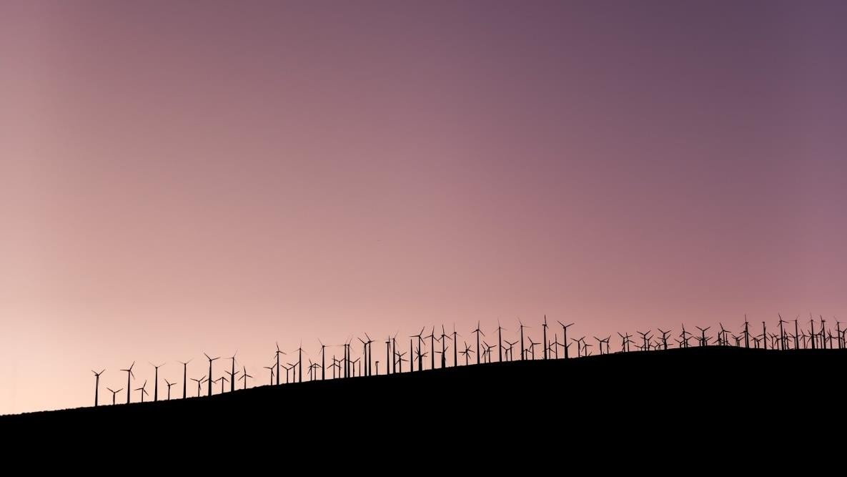

Wind is a plentiful source of clean energy. Wind farms are an increasingly familiar sight in the UK with wind power making an ever-increasing contribution to the National Grid. To harness electricity from wind energy, turbines are used to drive generators which then feed electricity into the National Grid. Although domestic or ‘off-grid’ generation systems are available, not every property is suitable for a domestic wind turbine.

Wind is used to produce electricity using the kinetic energy created by air in motion. This is transformed into electrical energy using wind turbines or wind energy conversion systems. Wind first hits a turbine’s blades, causing them to rotate and turn the turbine connected to them. That changes the kinetic energy to rotational energy, by moving a shaft which is connected to a generator, and thereby producing electrical energy through electromagnetism.

Wind-turbine capacity has increased over time. In 1985, typical turbines had a rated capacity of 0.05 megawatts (MW) and a rotor diameter of 15 metres. Today’s new wind power projects have turbine capacities of about 2 MW onshore and 3–5 MW offshore.

Commercially available wind turbines have reached 8 MW capacity, with rotor diameters of up to 164 metres. The average capacity of wind turbines increased from 1.6 MW in 2009 to 2 MW in 2014.

## HYDRO ENERGY –

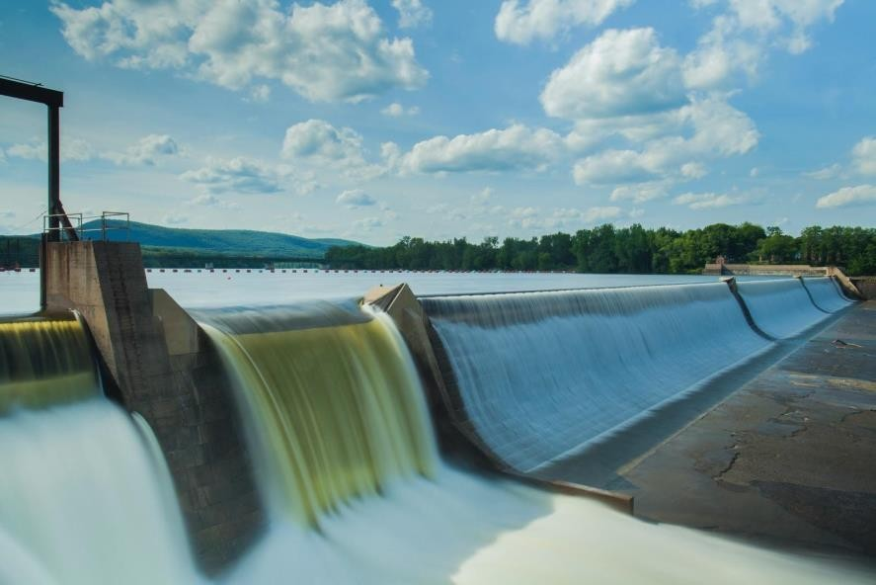

As a renewable energy resource, hydro power is one of the most commercially developed. By building a dam or barrier, a large reservoir can be used to create a controlled flow of water that will drive a turbine, generating electricity. This energy source can often be more reliable than solar or wind power (especially if it's tidal rather than river) and also allows electricity to be stored for use when demand reaches a peak. Like wind energy, in certain situations hydro can be more viable as a commercial energy source (dependant on type and compared to other sources of energy) but depending very much on the type of property, it can be used for domestic, ‘off-grid’ generation.

While most people might associate the energy source with the Hoover Dam—a huge facility harnessing the power of an entire river behind its wall—hydropower facilities come in all sizes. Some may be very large, but they can be tiny, too, taking advantage of water flows in municipal water facilities or irrigation ditches. They can even be “damless,” with diversions or run-of-river facilities that channel part of a stream through a powerhouse before the water rejoins the main river. Whatever the method, hydropower is much easier to obtain and more widely used than most people realize. In fact, all but two states (Delaware and Mississippi) use hydropower for electricity, some more than others. For example, about 74% of the state of Washington’s electricity comes from hydropower.

## TIDAL ENERGY –



This is another form of hydro energy that uses twice-daily tidal currents to drive turbine generators. Although tidal flow unlike some other hydro energy sources isn’t constant, it is highly predictable and can therefore compensate for the periods when the tide current is low.

Tidal turbines are similar to wind turbines in that they have blades that turn a rotor to power a generator. They can be placed on the sea floor where there is strong tidal flow. Because water is about 800 times denser than air, tidal turbines have to be much sturdier and heavier than wind turbines. Tidal turbines are more expensive to build than wind turbines but can capture more energy with the same size blades.

A potential disadvantage of tidal power is the effect a tidal station can have on plants and animals in estuaries of the tidal basin. Tidal barrages can change the tidal level in the basin and increase turbidity (the amount of matter in suspension in the water). They can also affect navigation and recreation.

## Geothermal energy -

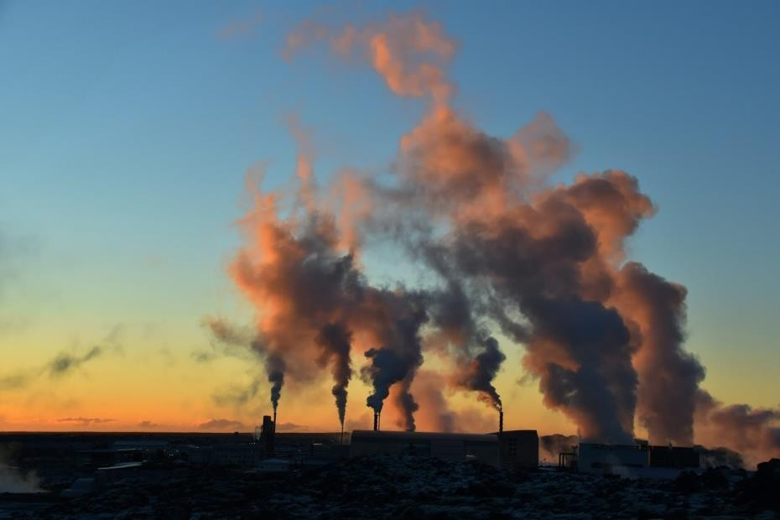

By harnessing the natural heat below the earth’s surface, geothermal energy can be used to heat homes directly or to generate electricity. Although it harnesses a power directly below our feet, geothermal energy is of negligible importance in the UK compared to countries such as Iceland, where geothermal heat is much more freely available.

The slow decay of radioactive particles in the earth's core, a process that happens in all rocks, produces geothermal energy.

The earth has four major parts or layers:

* + An inner core of solid iron that is about 1,500 miles in diameter
  + An outer core of hot molten rock called magma that is about 1,500 miles thick.
  + A mantle of magma and rock surrounding the outer core that is about 1,800 miles thick
  + A crust of solid rock that forms the continents and ocean floors that is 15 to 35 miles thick under the continents and 3 to 5 miles thick under the oceans.

The earth's crust is broken into pieces called tectonic plates. Magma comes close to the earth's surface near the edges of these plates, which is where many volcanoes occur. The lava that erupts from volcanoes is partly magma. Rocks and water absorb heat from magma deep underground. The rocks and water found deeper underground have the highest temperatures.

## BIOMASS ENERGY –



This is the conversion of solid fuel made from plant materials into electricity. Although fundamentally, biomass involves burning organic materials to produce electricity, and nowadays this is a much cleaner, more energy-efficient process. By converting agricultural, industrial and domestic waste into solid, liquid and gas fuel, biomass generates power at a much lower economic and environmental cost.

Biomass can also be directly converted to energy through gasification. During the gasification process, a biomass feedstock (usually MSW) is heated to more than 700° C (1,300° F) with a controlled amount of oxygen. The molecules break down, and produce syngas and slag.

Biomass can also be co-fired, or burned with a fossil fuel. Biomass is most often co- fired in coal plants. Co-firing eliminates the need for new factories for processing biomass. Co-firing also eases the demand for coal. This reduces the amount of carbon dioxide and other greenhouse gases released by burning fossil fuels.

Biomass can be burned by thermal conversion and used for energy. Thermal conversion involves heating the biomass feedstock in order to burn, dehydrate, or stabilize it. The most familiar biomass feedstocks for thermal conversion are raw materials such as municipal solid waste (MSW) and scraps from paper or lumber mills.

# Conclusions -

Renewable energy sources have a broad range of total systemwide occupational health and safety impacts, but a relatively narrow range of average risk to individual workers. Nearly all of the renewable energy sources studied have greater total systemwide impacts than a representative coal fuel cycle, reflecting a greater energy and labor intensity per unit energy delivered. Roughly half of the renewable energy sources, however, have lower average risk to individual workers.

Central station photovoltaics and passive solar heating stand alone as the least risky of the technologies examined, with respect to both total systemwide risk and average individual risk. Residential wind with no storage and wood [pyrolysis](https://www.sciencedirect.com/topics/biochemistry-genetics-and-molecular-biology/pyrolysis) are the riskiest.

Considerable caution must be exercised in using these results to compare relative impacts of renewable energy sources. They neither produce the same end form of energy nor can they be directly substituted for one another. The results presented here should, therefore, be taken only as indicators of potential differences.

Energy is sustainable if it "meets the needs of the present without compromising the ability of future generations to meet their own needs". Most definitions of sustainable energy include considerations of environmental aspects such as greenhouse gas emissions and social and economic aspects such as energy poverty. Renewable energy sources such as wind, hydroelectric power, solar, and geothermal energy are generally far more sustainable than fossil fuel sources. However, some renewable energy projects, such as the clearing of forests to produce biofuels, can cause severe environmental damage. The role of non-renewable energy sources in sustainable energy has been controversial. Nuclear power is a low-carbon source whose historic mortality rates are comparable to wind and solar, but its sustainability has been debated because of concerns about radioactive waste, nuclear proliferation, and accidents. Switching from coal to natural gas has environmental benefits, including a lower climate impact, but may lead to a delay in switching to more sustainable options. Carbon capture and storage can be built into power plants to remove their carbon dioxide (CO2) emissions, but is expensive and has seldom been implemented.